Liberia

## Freedom House political status

The data set shows the Freedom House political scores and status of the country each year.

## # A tibble: 19 x 5  
## country iso3c date mean status   
## <chr> <chr> <dbl> <dbl> <chr>   
## 1 Liberia LBR 1996 6.5 Not Free   
## 2 Liberia LBR 1998 4.5 Partly Free  
## 3 Liberia LBR 2000 5.5 Partly Free  
## 4 Liberia LBR 2002 6 Not Free   
## 5 Liberia LBR 2003 6 Not Free   
## 6 Liberia LBR 2004 4.5 Partly Free  
## 7 Liberia LBR 2005 4 Partly Free  
## 8 Liberia LBR 2006 3.5 Partly Free  
## 9 Liberia LBR 2007 3.5 Partly Free  
## 10 Liberia LBR 2008 3.5 Partly Free  
## 11 Liberia LBR 2009 3.5 Partly Free  
## 12 Liberia LBR 2010 3.5 Partly Free  
## 13 Liberia LBR 2011 3.5 Partly Free  
## 14 Liberia LBR 2012 3.5 Partly Free  
## 15 Liberia LBR 2013 3.5 Partly Free  
## 16 Liberia LBR 2014 3.5 Partly Free  
## 17 Liberia LBR 2015 3.5 Partly Free  
## 18 Liberia LBR 2016 3.5 Partly Free  
## 19 Liberia LBR 2017 3 Partly Free

## Freedom House classification of political change

The data set shows the GDP growth and the ecomic growth classification of the country each year.

## # A tibble: 19 x 4  
## country iso3c date politicalChangeFH  
## <chr> <chr> <dbl> <chr>   
## 1 Liberia LBR 1996 no change   
## 2 Liberia LBR 1998 no change   
## 3 Liberia LBR 2000 autocratization   
## 4 Liberia LBR 2002 no change   
## 5 Liberia LBR 2003 no change   
## 6 Liberia LBR 2004 democratization   
## 7 Liberia LBR 2005 democratization   
## 8 Liberia LBR 2006 democratization   
## 9 Liberia LBR 2007 no change   
## 10 Liberia LBR 2008 no change   
## 11 Liberia LBR 2009 no change   
## 12 Liberia LBR 2010 no change   
## 13 Liberia LBR 2011 no change   
## 14 Liberia LBR 2012 no change   
## 15 Liberia LBR 2013 no change   
## 16 Liberia LBR 2014 no change   
## 17 Liberia LBR 2015 no change   
## 18 Liberia LBR 2016 no change   
## 19 Liberia LBR 2017 democratization

## Freedom House score trend

The plot shows the Freedom House scores trend of the country.

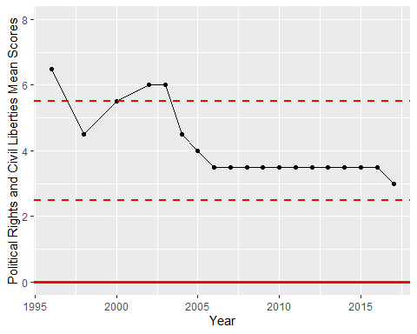

Freedom House Score Trend